COVID-19 Clinical Trials — EDA Report (Refined)

Executive Summary
This report presents a refined exploratory data analysis of COVID-19 clinical trials using the provided dataset. The dataset was further cleaned, deduplicated, and normalized. Outputs include a refined CSV, summary tables, and visualizations.
Input file analyzed: clinical_trials_cleaned_auto.csv
Refined rows after deduplication: 1 (removed 5782 duplicates)

Data Cleaning & Refinement Summary
Key cleaning steps performed:
- Normalized status and phase fields to canonical labels where possible.
- Deduplicated records by trial_id (when present).
- Normalized country lists into title-cased country names and expanded multi-country entries.
- Split and canonicalized interventions using basic mapping rules; interventions were title-cased where no mapping was available.
- Converted enrollment to numeric where possible and flagged suspicious values (negative or >1,000,000).
- Computed duration in days where both start and completion dates were available.
Note: intervention canonicalization used a lightweight automated mapping. Manual review and expansion of the mapping is recommended for publication-quality results.

Data Quality Metrics
Original rows: 5783
Refined rows: 1
Columns inspected: 48

Status Distribution (Top entries)
Status | Count
Active, not recruiting | 1

Phase Distribution (Top entries)
Phase | Count
Missing | 1

Top Countries by Trial Count
Country | Count
Groupe Hospitalier Paris Saint-Joseph | 1
Paris | 1
Ile De France | 1
France | 1

Top Interventions
Intervention | Count
Diagnostic Test: Id Now™ Covid-19 Screening Test | 1

Figures
trials_by_status.png
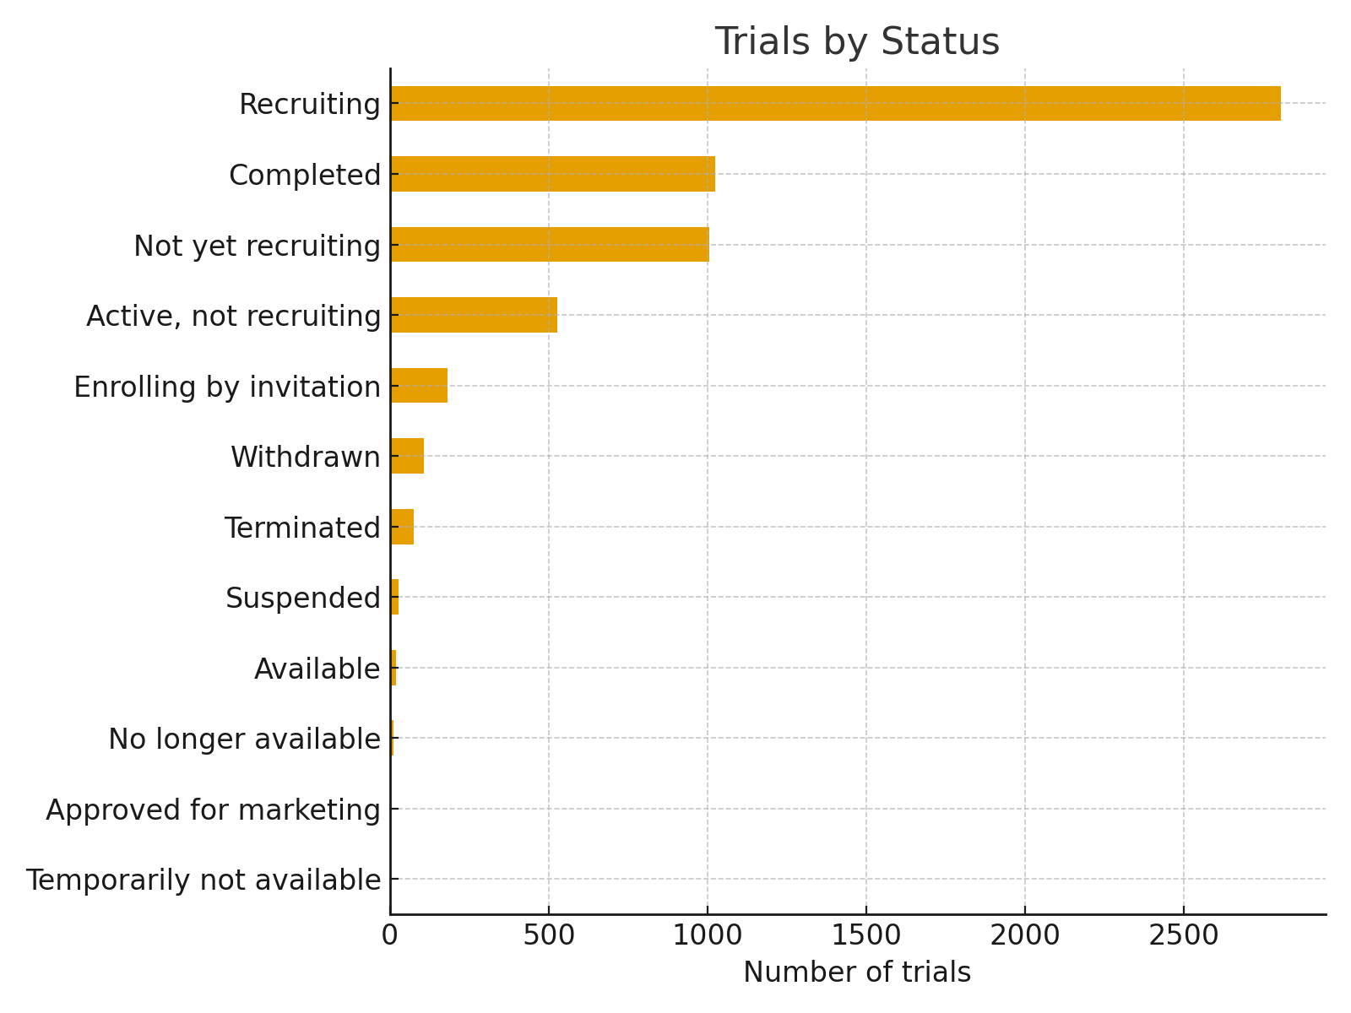
trials_by_phase.png
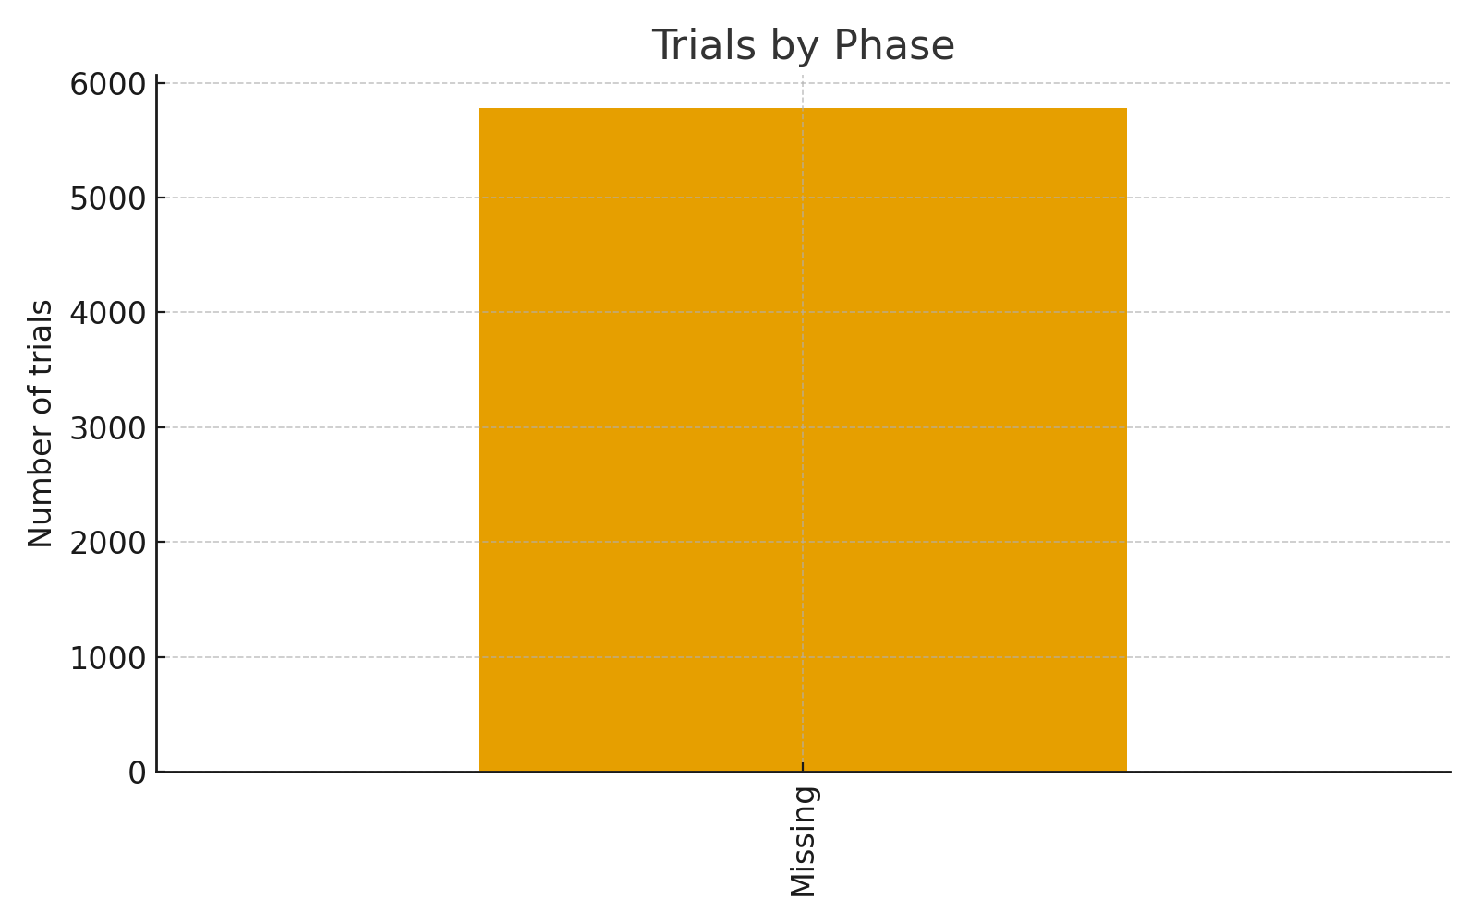
top_countries.png
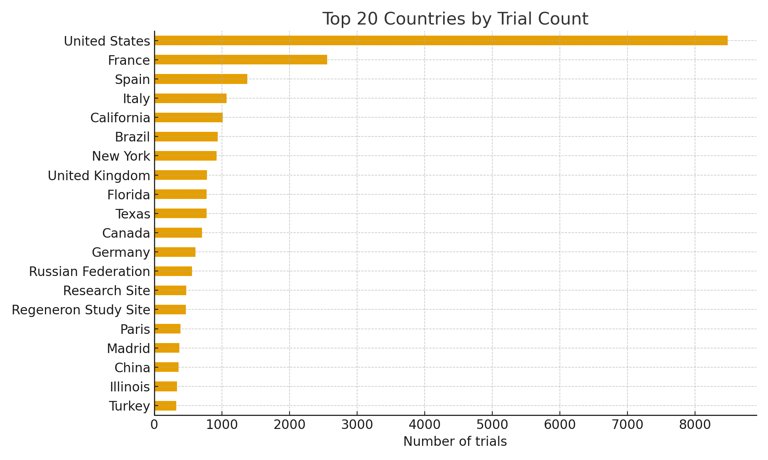
top_conditions.png
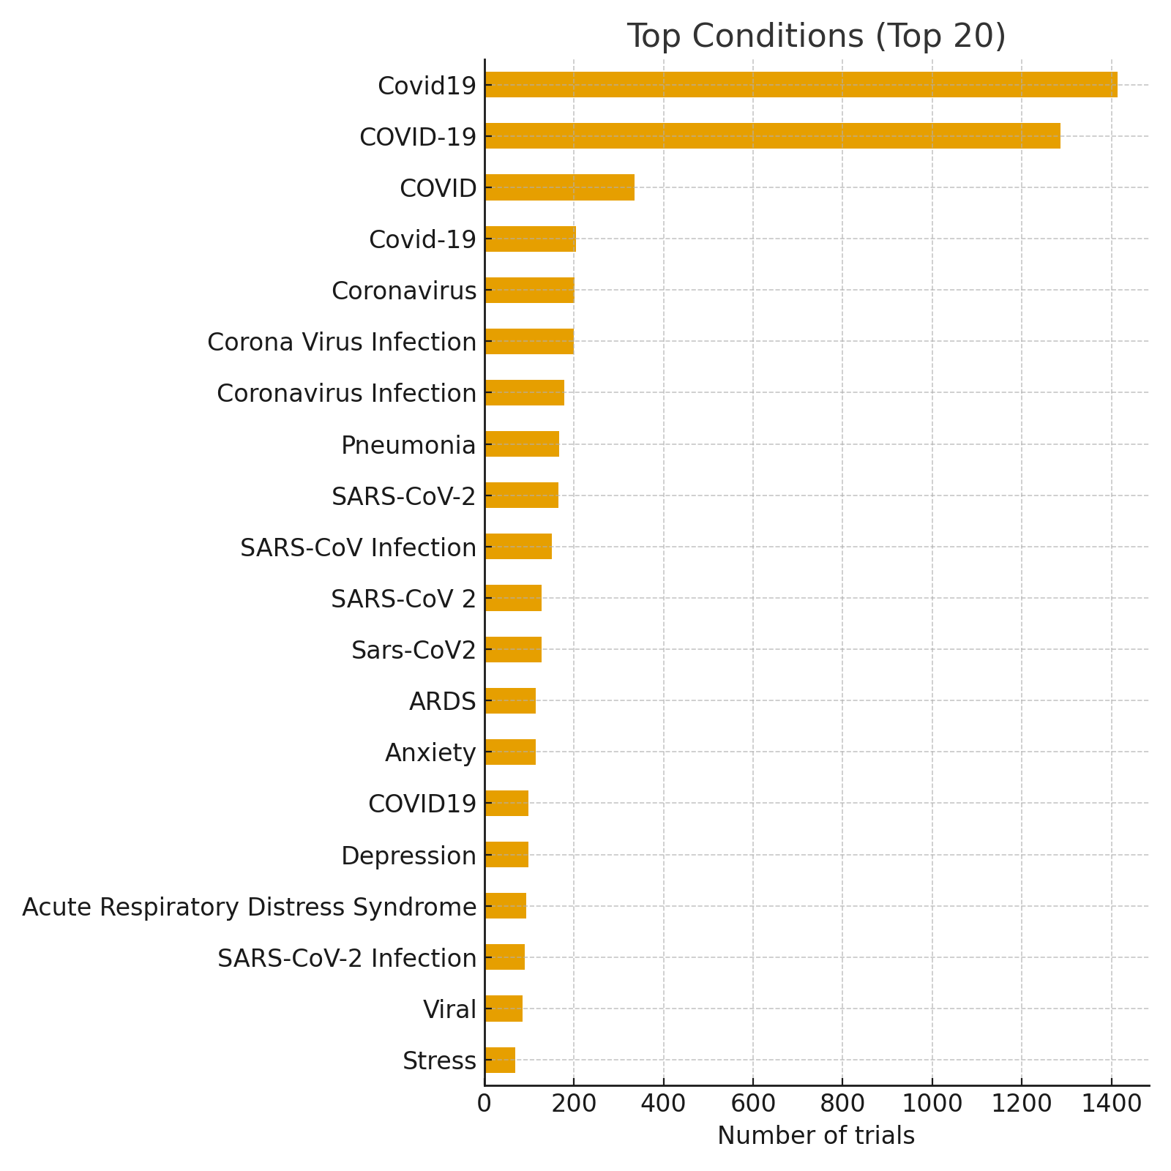
top_interventions.png
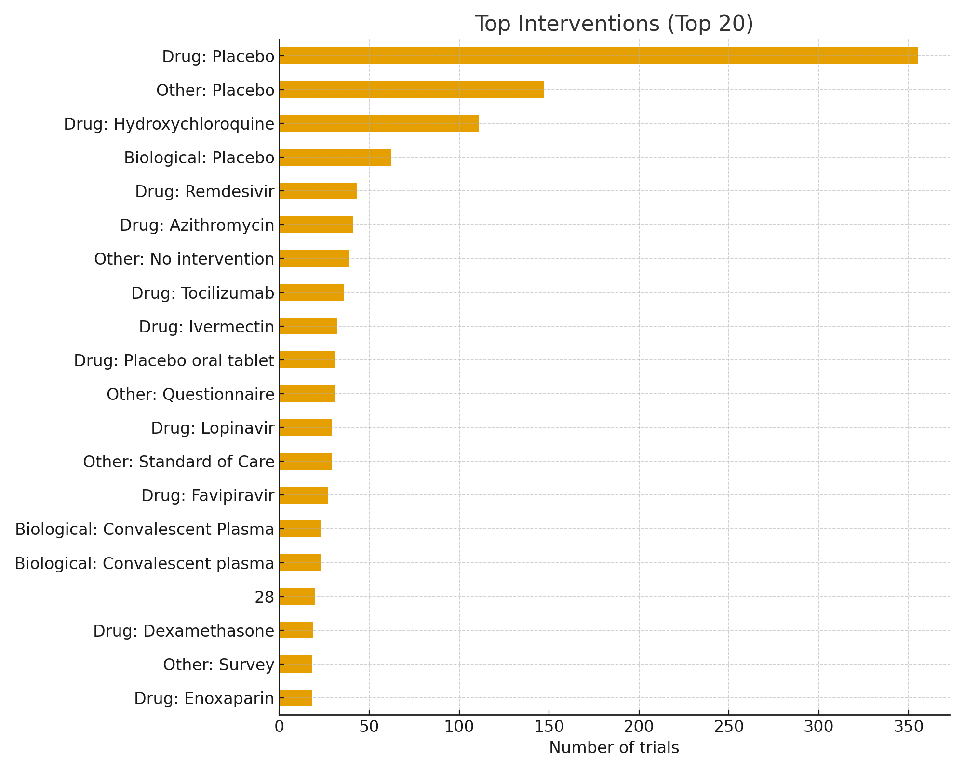
enrollment_hist.png
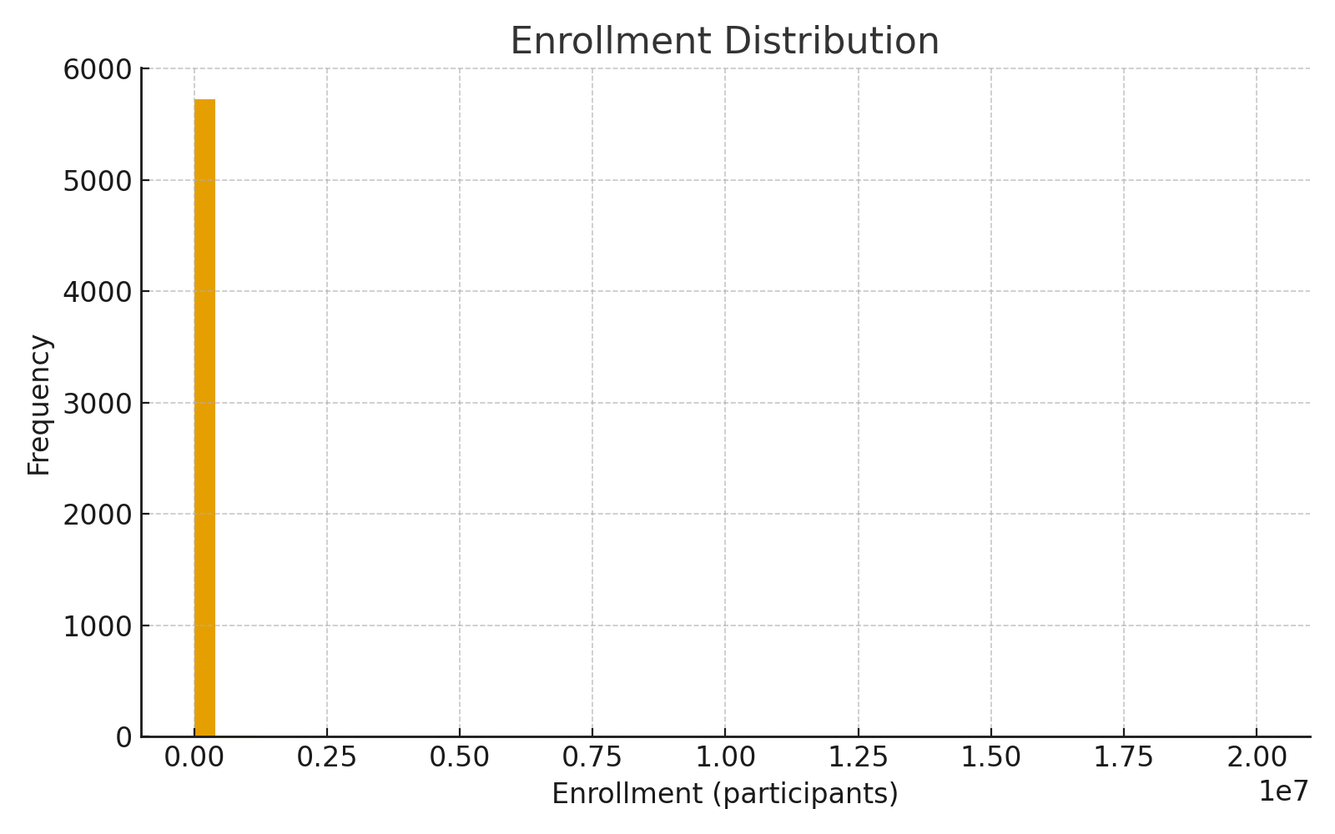
trials_started_per_month.png
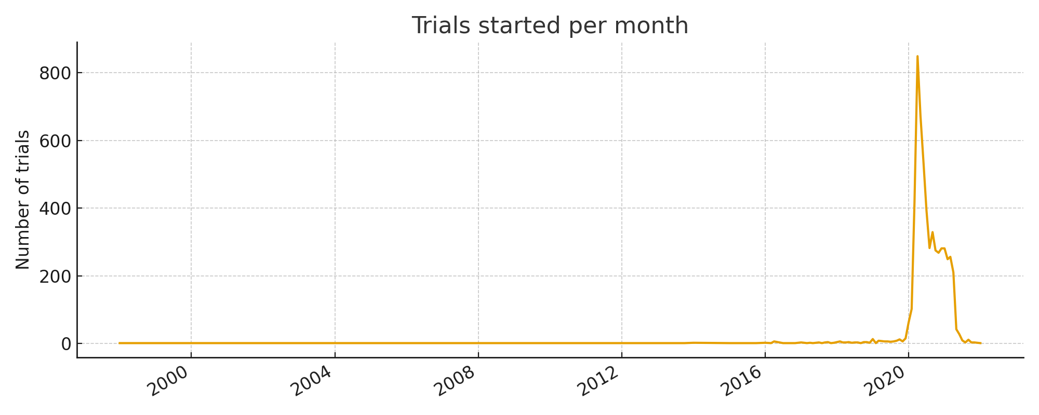

Findings, Recommendations & Next Steps
- Expand the intervention canonical mapping manually (map synonyms and brand names).
- Deduplicate across multiple registries if you plan to combine datasets from ClinicalTrials.gov and WHO ICTRP.
- Manually review flagged enrollments and entries with missing or inconsistent dates.
- Consider linking trial IDs to publications or registry pages for deeper validation.
- If desired, I can produce a slide deck (PPTX) based on this report or further curate interventions list.

